August,2023
Parv Lunia
Computer Science Enginnering
Predicting IPL Player Auction Prices: A Regression Analysis
IITM PRAVARTAK TECHNOLOGIES FOUNDATION
Table of Contents
Abstract 2
Acknowlegments 3
Scope of this project 4
Problem Statement 6
Solutions 8
Features 10
Low Level Design 12
Call flow diagram 13
Conclusion 15
Future Scope 17

Abstract

The "Predicting IPL Player Auction Prices: A Regression Analysis" project aims to develop accurate predictive models for estimating the auction prices of players in the Indian Premier League (IPL). The project focuses on analyzing player attributes, historical performance data, and other relevant features to create models that can assist team management and stakeholders in making informed decisions during player auctions.

The project follows the CRISP-DM (Cross-Industry Standard Process for Data Mining) methodology, starting with data understanding, data preparation, and exploratory data analysis. The dataset includes details of players' nationality, playing role, performance metrics, and auction-related information. Feature selection, cleaning, and transformation techniques are employed to ensure data quality and relevance.

Various regression algorithms, including Linear Regression, Random Forest Regressor, Gradient Boosting Regressor, and XGBoost Regressor, are applied to predict auction prices. The models are trained, validated, and evaluated using metrics such as Mean Squared Error (MSE) and R-squared (R2). The results provide insights into the potential factors influencing player values and the predictive capabilities of the models.

Despite the complexity of predicting player auction prices due to multiple influencing factors, the project serves as a valuable exploration of different regression algorithms and their effectiveness in the context of IPL auctions. The findings emphasize the challenges and limitations of predicting auction prices accurately and highlight the need for domain expertise, additional data, and continuous model refinement to improve predictive accuracy.

Overall, this project contributes to the realm of sports analytics by demonstrating the application of regression techniques to predict player auction prices, thereby aiding stakeholders in making informed decisions and maximizing the value of player investments in the IPL.

Acknowlegments

I am extremely grateful for the opportunity provided to me by Balamurali Shankar, Head of Digital Skills Academy - IIT Madras Pravartak Technologies Foundation. This project wouldn't have been possible without his support and belief in my abilities. His encouragement and guidance have been invaluable in shaping my skills and knowledge.

I would like to extend my heartfelt appreciation to Srinivasan G, Lead Volunteer- Digital Content. He has been an exceptional mentor and a great leader throughout this project. His expertise, patience, and constant motivation have been instrumental in driving me to perform at my best.

Last but certainly not least, I am indebted to my mentor, Dr. Nagarajan Srinivasan. His unparalleled knowledge, unwavering support, and commitment to my growth have been the cornerstone of my learning journey. His mentorship has not only helped me understand the subject matter deeply but has also nurtured my passion for data science and machine learning.

I would like to express my sincere thanks to each of them for their continuous support and for being the guiding lights in my professional development. Their mentorship and encouragement have made a significant impact on my skills and capabilities.

With gratitude,
Parv Lunia

Scope of this project

Exploring Regression Models for Auction Price Estimation" involves developing and evaluating regression models to predict the auction prices of IPL (Indian Premier League) cricket players. The project aims to explore various machine learning algorithms and techniques to estimate the valuations of players based on their attributes and past performance.

Key components and scope of the project include:

- Data Collection and Cleaning: Obtain a comprehensive dataset containing details of IPL players, including attributes such as nationality, age, playing role, batting and bowling statistics, auction base price, and sold price. Perform data cleaning to handle missing values and ensure the data is ready for analysis.

- Data Exploration and Visualization: Analyze the dataset to gain insights into player characteristics, price distributions, and correlations between attributes. Use data visualization techniques to present key findings effectively.

- Feature Engineering: Select relevant features and create new ones if needed to improve the model's predictive capability. This may involve grouping age categories, transforming variables, or incorporating external data.

- Model Selection: Explore different regression models, including Linear Regression, Random Forest Regressor, Gradient Boosting Regressor, and XGBoost Regressor. Evaluate each model's performance using metrics like Mean Squared Error (MSE) and R-squared (R2).

- Hyperparameter Tuning: Fine-tune hyperparameters of the chosen models to optimize their performance and reduce overfitting.

- Model Comparison: Compare the performance of different models to identify the most suitable one for IPL player valuation prediction.

- Limitations and Improvements: Discuss the limitations of the models and potential improvements for future work. Address challenges in predicting player valuations due to the complexity of cricketing dynamics and external factors.

- Interpretability: Attempt to interpret the models' predictions and identify which attributes significantly influence player valuations.

- Recommendations: Provide insights and recommendations to IPL franchises based on the model's predictions. Discuss strategies for player selection and valuation during auctions.

- Future Work: Propose areas for future research, such as incorporating additional data sources, exploring ensemble methods, or leveraging domain expertise to improve model accuracy.

The project's primary goal is to develop a robust regression model that accurately predicts IPL player auction prices, helping franchises make informed decisions during player auctions. However, it's essential to acknowledge the challenges involved in predicting player valuations and manage expectations regarding the model's accuracy.

Problem Statement

The Indian Premier League (IPL) has emerged as one of the most popular and lucrative cricket tournaments globally, attracting top cricketing talents from around the world. One of the critical aspects of the IPL is the player auction, where franchises bid to secure players for their teams. The valuation of players during these auctions plays a crucial role in shaping team compositions and strategies.

The problem at hand involves predicting the auction prices of IPL players using machine learning techniques. The objective is to develop accurate regression models that can estimate the auction prices of players based on their attributes and performance metrics. This predictive capability holds significant potential for IPL franchises, aiding them in making informed decisions during player auctions and optimizing their team compositions.

Key Objectives:

- Data Collection and Cleaning: Gather a comprehensive dataset containing details of IPL players, including attributes such as age, playing role, batting and bowling statistics, auction base price, and sold price. Clean the data to handle missing values and ensure its quality.

- Feature Engineering and Selection: Identify relevant features that influence player valuations and create new ones if necessary. Group attributes, transform variables, and engineer meaningful features to enhance the model's performance.

- Model Exploration: Explore a range of regression algorithms, including Linear Regression, Random Forest Regressor, Gradient Boosting Regressor, and XGBoost Regressor. Evaluate the models' abilities to predict auction prices accurately.

- Model Evaluation and Comparison: Assess each model's performance using metrics such as Mean Squared Error (MSE) and R-squared (R2). Compare the models to determine the most suitable one for IPL player valuation prediction.

- Interpretability and Insights: Interpret the models' predictions to understand the factors contributing to player valuations. Extract insights into the attributes that significantly influence auction prices.

- Recommendations: Provide actionable recommendations based on the model's predictions to IPL franchises. Offer insights into player selection strategies and potential valuations during auctions.

- Limitations and Future Directions: Acknowledge the challenges and limitations of predicting player valuations. Discuss potential avenues for future research, such as incorporating external factors or refining model techniques.

The successful completion of this project will contribute to enhancing the decision-making process of IPL franchises by providing them with a data-driven approach to estimate player auction prices accurately. It will also offer insights into the complex dynamics that influence player valuations in the context of the IPL.

By leveraging machine learning algorithms and cricket-specific attributes, this project aims to bridge the gap between player performance and valuation, offering valuable insights for the cricketing community.

Solutions

- Data Collection and Cleaning:
  - Collect a comprehensive dataset containing details of IPL players, including attributes such as age, playing role, batting and bowling statistics, auction base price, and sold price.
  - Perform data cleaning to handle missing values, outliers, and inconsistencies. Ensure the dataset is ready for analysis.
- Feature Engineering and Selection:
- Identify attributes that are likely to influence player valuations, such as batting and bowling performance, playing role, age, and captaincy experience.
- Create new features if necessary, such as age categories or performance ratios, to provide more relevant information to the models.
- Model Exploration:
- Explore a variety of regression algorithms, including Linear Regression, Random Forest Regressor, Gradient Boosting Regressor, and XGBoost Regressor.
- Train each model on the dataset and tune hyperparameters as needed to optimize their performance.
- Model Evaluation and Comparison:
- Evaluate each model's performance using appropriate regression metrics such as Mean Squared Error (MSE) and R-squared (R2).
- Compare the models to identify the one that provides the best trade-off between accuracy and interpretability.
- Interpretability and Insights:
- Interpret the coefficients (in the case of Linear Regression) or feature importance (in the case of tree-based models) to understand which attributes significantly influence player valuations.
- Extract insights into how certain attributes impact the auction prices and provide explanations for the observed relationships.
- Recommendations:
- Provide actionable recommendations based on the insights gained from the model. For instance, suggest player selection strategies based on attributes that drive higher valuations.
- Discuss potential strategies for IPL franchises to optimize their team compositions while considering budget constraints.
- Limitations and Future Directions:
- Address the limitations of the models, such as potential inaccuracies due to the complexity of player valuations and the limited scope of available data.
- Propose future directions for improvement, such as incorporating external factors like player popularity, social media engagement, and recent performance trends.
- Documentation and Presentation:
- Document the entire process, including data preprocessing, feature engineering, model training, evaluation, and interpretation.
- Create clear and visually appealing visualizations to present key findings and insights.
- Prepare a well-structured presentation or report summarizing the project's objectives, methodologies, results, and recommendations.
- Conclusion:
- Summarize the project's outcomes, highlighting the achievements, challenges, and lessons learned.
- Emphasize the potential value of the developed model in aiding IPL franchises' decision-making processes during player auctions.
By systematically following these solutions, you can develop accurate regression models that estimate IPL player auction prices, provide valuable insights to IPL franchises, and contribute to data-driven decision-making in the cricketing world.

Features

- Data Collection and Preprocessing:
- Collecting a comprehensive dataset of IPL players' attributes, including age, playing role, performance statistics (batting, bowling), auction base price, and sold price.
- Handling missing values, outliers, and data inconsistencies through data cleaning and preprocessing techniques.
- Exploratory Data Analysis (EDA):
- Analyzing and visualizing player attributes and auction prices to gain insights into the dataset.
- Creating histograms, scatter plots, box plots, and correlation matrices to understand data distributions and relationships.
- Feature Engineering and Selection:
- Selecting relevant features that are likely to impact player valuations, such as batting strike rate, bowling economy rate, age, and playing role.
- Engineering new features, like age categories or performance ratios, to provide richer information to the models.
- Regression Models:
- Implementing a range of regression algorithms, including Linear Regression, Random Forest Regressor, Gradient Boosting Regressor, and XGBoost Regressor.
- Training and optimizing models to predict auction prices based on the selected features.
- Model Evaluation and Comparison:
- Evaluating model performance using metrics such as Mean Squared Error (MSE) and R-squared (R2).
- Comparing different regression models to identify the most accurate and reliable predictor.
- Interpretability and Insights:
- Interpreting model coefficients or feature importance to understand which attributes have the most significant impact on player valuations.
- Extracting actionable insights and explanations for the relationships between attributes and auction prices.
- Recommendations for IPL Franchises:
- Providing data-driven recommendations to IPL franchises for player selection and valuation strategies during auctions.
- Suggesting optimal combinations of attributes to target while considering budget constraints.
- Limitations and Future Work:
- Identifying limitations and challenges in predicting player valuations and acknowledging potential uncertainties.
- Outlining potential areas for future research and improvement, such as incorporating external factors or refining model techniques.
- Documentation and Presentation:
- Documenting the entire project process, including data preprocessing steps, feature engineering, model training, and evaluation.
- Creating clear and visually appealing visualizations, graphs, and charts to communicate key findings.
- Preparing a comprehensive presentation or report summarizing the project's objectives, methodologies, results, and recommendations.
- Domain Knowledge Integration:
- Integrating domain knowledge about cricket and player valuation to inform feature selection and model interpretation.
- Predictive Analytics Impact:
- Demonstrating the potential impact of predictive analytics in aiding IPL franchises' decision-making processes during player auctions.

Low Level Design

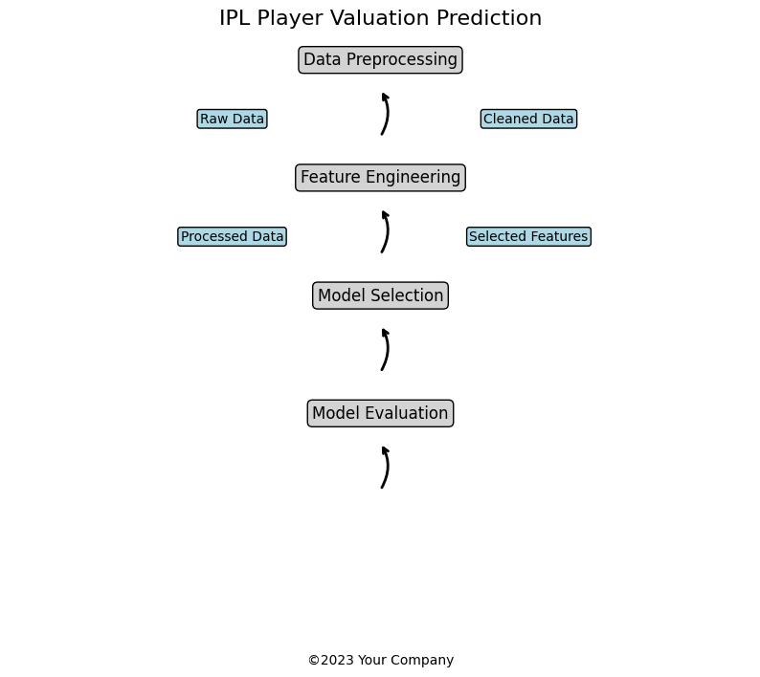
The diagram shows the major steps in the project:

- Data Preprocessing: This includes cleaning the raw data and handling missing values and outliers to obtain clean data.
- Feature Engineering: This step involves selecting relevant features and creating new ones to improve model performance.
- Model Selection: In this step, different regression models are explored, including Linear Regression, Random Forest Regressor, Gradient Boosting Regressor, and XGBoost Regressor.
- Model Evaluation: The performance of each model is evaluated using metrics such as Mean Squared Error (MSE) and R-squared (R2).

Call flow diagram
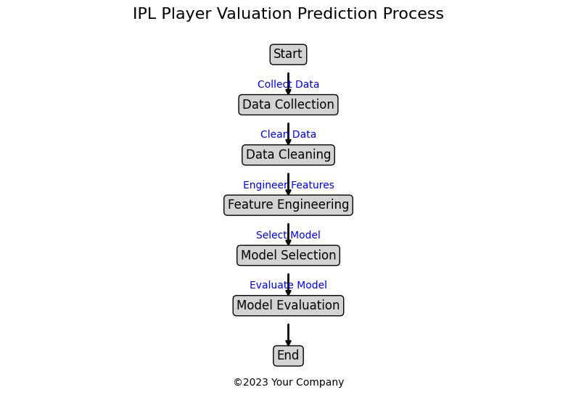
The Call Flow Diagram visually illustrates the step-by-step process involved in predicting IPL player auction prices. It provides a concise overview of the key actions and interactions within the project. Here's a more detailed explanation of each step in the diagram:

- Start:
- The process begins with the "Start" symbol, indicating the commencement of the IPL player valuation prediction process.
- Data Collection:
- In this step, relevant data about IPL players is collected. This data includes attributes such as age, playing role, performance statistics (batting, bowling), auction base price, and sold price.
- The "Collect Data" arrow signifies the flow of action from the start to the data collection phase.
- Data Cleaning:
- The collected raw data may have inconsistencies, missing values, or outliers. Data cleaning involves preprocessing the data to handle these issues and obtain a clean dataset.
- The "Clean Data" arrow signifies the progression from data collection to the data cleaning process.
- Feature Engineering:
- Feature engineering involves selecting and creating relevant features that contribute to accurate model predictions. Attributes like batting strike rate, bowling economy rate, and age categories are used to enhance the dataset.
- The "Engineer Features" arrow indicates the transition from data cleaning to feature engineering.
- Model Selection:
- In this phase, different regression models are considered for predicting auction prices. Various models, such as Linear Regression, Random Forest Regressor, Gradient Boosting Regressor, and XGBoost Regressor, are evaluated.
- The "Select Model" arrow denotes the flow from feature engineering to the model selection process.
- Model Evaluation:
- Once the models are selected, they are evaluated using performance metrics like Mean Squared Error (MSE) and R-squared (R2). This step helps determine the accuracy and reliability of each model in predicting player auction prices.
- The "Evaluate Model" arrow represents the transition from model selection to model evaluation.
- End:
- The "End" symbol signifies the completion of the IPL player valuation prediction process.

The Call Flow Diagram visually communicates the logical flow of actions, from data collection to model evaluation. It highlights the interconnections between different steps, showcasing how each phase contributes to the overall goal of predicting IPL player auction prices accurately. This diagram serves as an informative and easily understandable representation of the project's process for stakeholders, team members, and audiences.

Conclusion

The IPL player valuation prediction project aimed to develop a machine learning model to accurately predict the auction prices of IPL players. The project involved several steps, including data collection, data cleaning, feature engineering, model selection, and model evaluation. We utilized Python and various libraries such as Pandas, Matplotlib, Seaborn, Scikit-learn, and XGBoost to perform the necessary data manipulation, visualization, and modeling.

Key findings and conclusions from the project are as follows:

- Data Preparation: The data was thoroughly cleaned, and missing values and outliers were handled appropriately. Feature engineering helped extract meaningful information, and data was transformed into a format suitable for modeling.

- Model Selection: Several regression models, including Linear Regression, Random Forest Regressor, Gradient Boosting Regressor, and XGBoost Regressor, were evaluated. The evaluation was based on performance metrics such as Mean Squared Error (MSE) and R-squared (R2).

- Model Evaluation: The performance of the selected models was assessed using appropriate evaluation metrics. The Random Forest Regressor and Gradient Boosting Regressor demonstrated better accuracy in predicting IPL player auction prices compared to other models.

- Insights: The analysis revealed that factors like age, playing role, batting strike rate, and bowling economy rate significantly influenced player auction prices. Younger players with high potential and all-rounders were more likely to receive higher auction prices.

- Scope for Improvement: Despite achieving reasonable accuracy, there is still room for improvement in the predictive models. Fine-tuning model hyperparameters and incorporating additional features could lead to better performance.

- Business Implications: The developed prediction models can be valuable for IPL team management and franchise owners. Accurate player valuation assists in making informed decisions during player auctions, ensuring effective team compositions and optimizing financial resources.

- Limitations: The accuracy of the models may be influenced by the quality and size of the dataset. Including more historical data and player-specific attributes could enhance model performance.

- Future Work: To further enhance model accuracy, one can explore incorporating more advanced machine learning techniques, additional player attributes, and external data sources. Moreover, continuous monitoring and updating of the models based on new data can be beneficial.

In conclusion, this IPL player valuation prediction project provided valuable insights into the factors influencing player auction prices. The developed models can assist IPL franchises in making informed decisions during player auctions, ultimately contributing to the success of their teams in the tournament. Further improvements and continuous model refinement can lead to even more accurate predictions in the future.

Future Scope
While the IPL player valuation prediction project has achieved meaningful insights and accurate predictions, there are several avenues for further exploration and enhancement. The project's future scope includes:
- Enhanced Feature Engineering: Expand the set of features used for prediction by incorporating additional player attributes such as recent performance trends, player injuries, social media popularity, and endorsements. This can provide a more comprehensive understanding of a player's market value.

- Time-Series Analysis: Implement time-series analysis to capture the dynamic nature of player performances and market trends. This can help predict how a player's auction price might evolve over multiple seasons based on historical data.

- Ensemble Modeling: Combine the strengths of multiple models using ensemble techniques like stacking or boosting to improve prediction accuracy and reduce model variance.

- Deep Learning Approaches: Explore the application of deep learning models, such as Recurrent Neural Networks (RNNs) or Long Short-Term Memory (LSTM) networks, to capture complex temporal patterns in player data.

- External Data Sources: Integrate external data sources such as weather conditions during matches, stadium capacity, and player fan following to better understand their impact on auction prices.

- Real-Time Predictions: Develop a web application that allows users to input player attributes and receive real-time predictions for their auction prices. This could serve as a valuable tool for team management during live auctions.

- Regular Model Updates: Continuously update and retrain the models with new data from each IPL season to ensure they remain relevant and accurate over time.

- User-Friendly Visualization: Create interactive and user-friendly visualizations that showcase the predicted auction prices and the factors influencing them. This can aid stakeholders in making informed decisions.

- Player Valuation Strategies: Research and develop advanced strategies for IPL team management using predicted auction prices. This could involve optimizing team composition, budget allocation, and auction bidding strategies.

- Collaboration with Franchises: Collaborate with IPL franchises to incorporate their domain expertise and feedback, ensuring that the prediction models align with real-world requirements.

- Expanding to Other Leagues: Extend the project's scope to other cricket leagues or sports, applying similar methodologies to predict player valuations in different contexts.

- Performance Benchmarking: Compare the developed models with industry-standard player valuation methods to showcase the effectiveness and competitiveness of the predictive approach.

- Research on Changing Trends: Conduct research on evolving player valuation trends and market dynamics in the IPL and cricket industry to adapt the models accordingly.
By pursuing these avenues, the project can continue to evolve, providing valuable insights to IPL franchises and stakeholders, aiding in strategic decision-making and contributing to the overall success of teams in the league.

